Experiment no.:06 Keerthika.K-241901046
Extraction of Browser Artifacts
Aim
To extract and examine browser artifacts using forensic tools.
Procedure
- Open the appropriate browser forensic tool.
- Use ChromeHistoryView to read Google Chrome history data and display the list of visited web pages.
- Examine the available details for each visited webpage, such as URL, title, visit date/time, number of visits, typed count, referrer, and visit ID.
- Use ChromeCacheView to read the Google Chrome cache folder and display the files stored in the cache.
- Examine cache file details, including URL, content type, file size, last accessed time, expiration time, server name, and server response.
- Use IEHistoryView to read browser history and display URLs visited in the last few days.
- Examine the available history records. The tool also supports saving selected URL records in text, HTML, or XML format.
- Use IECacheView to read the Internet Explorer cache folder and display the files stored in it.
- Examine the cache details, including filename, content type, URL, last accessed time, last modified time, expiration time, number of hits, file size, folder name, and full path.
- Record the browser artifacts observed during the investigation.
Observation
Browser forensic tools help examine browser history and cache information. ChromeHistoryView displays visited webpage details, while ChromeCacheView displays files stored in the Chrome cache. IEHistoryView displays visited URLs, and IECacheView displays files and related details from the Internet Explorer cache.
Observation Table
S. No. | Tool Name | Information Examined
1 | ChromeHistoryView | URL, title, visit date/time, number of visits, typed count, referrer, visit ID
2 | ChromeCacheView | URL, content type, file size, last accessed time, expiration time, server details
3 | IEHistoryView | Visited URLs and browser history records
4 | IECacheView | Filename, content type, URL, access time, modified time, file size, cache path
5 | Result | Record the artifacts actually displayed by the tools

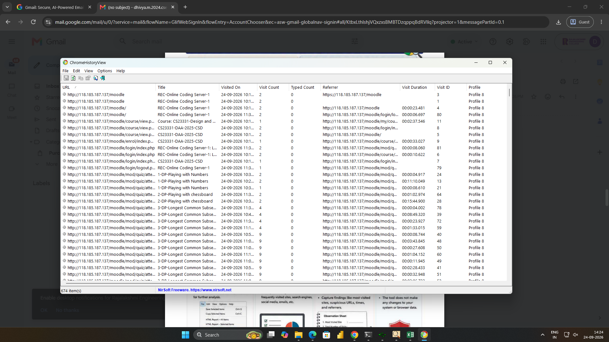

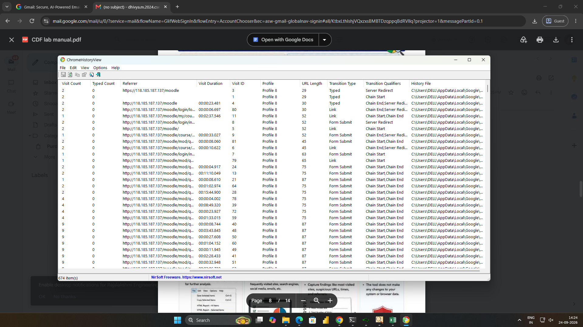

Result
Thus, browser forensic tools were studied to examine browser history and cache artifacts, and the available information was analyzed for forensic investigation.

